**Project Task list 4**

**TEAM: UNITED**

**[ Amrita Sodhi and Bharat Raj Verma ]**

**CONTENT**

**About us:**

With a large number of people facing eye disorders. Our clear focus on providing a better vision to millions with high-quality eye-wear at very affordable prices along with giving free eye checkups and reaching a large part of the people in need.

Our endeavor is to enhance your vision clarity and make it easy for you to see the vivid shades of the world. LET YOUR EYES TWINKLE!!!

**Our Mission**

Keeping in mind the cause, our mission is to make a difference on the whole by providing vision access to the underprivileged and beautifying lives. We are not just providing eyewear but an effective solution to the most ubiquitous issue among the society and the most sought after accessory to match people’s lifestyles. We are clear and concrete because we are hitting the bull’s-eye with a friendly and unique approach altogether. We aim to become a unique identity in the industry by communicating our ideology of delivering high quality eye-wear products to people without having them worry about their pockets.

**NAVIGATION BAR**

* Home
* Sunglasses
* Eyeglasses
* Lenses
* Book Appointment
* Contact us

**PAYEMENT OPTIONS**

* Visa
* Mastercard
* Net banking

**SHIPPING PARTNERS**

* FEDEX
* DHL

**Assets:**

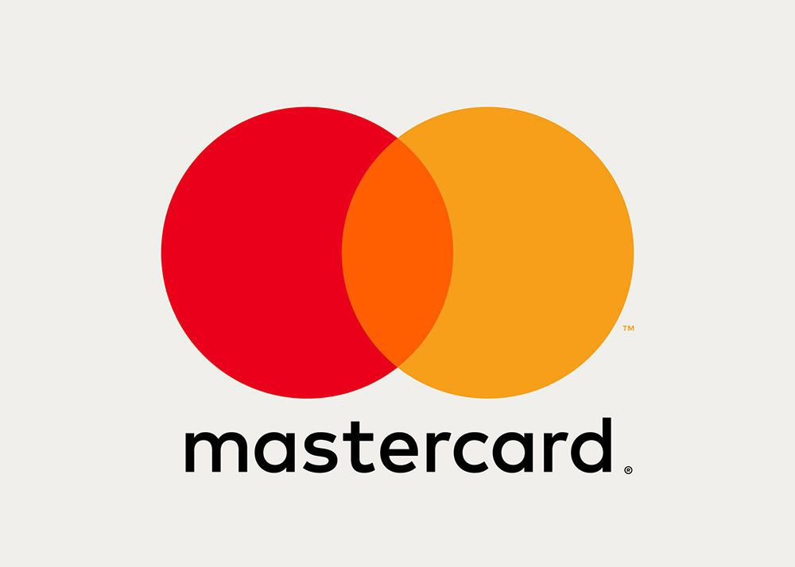



**WOMEN EYEWEAR**

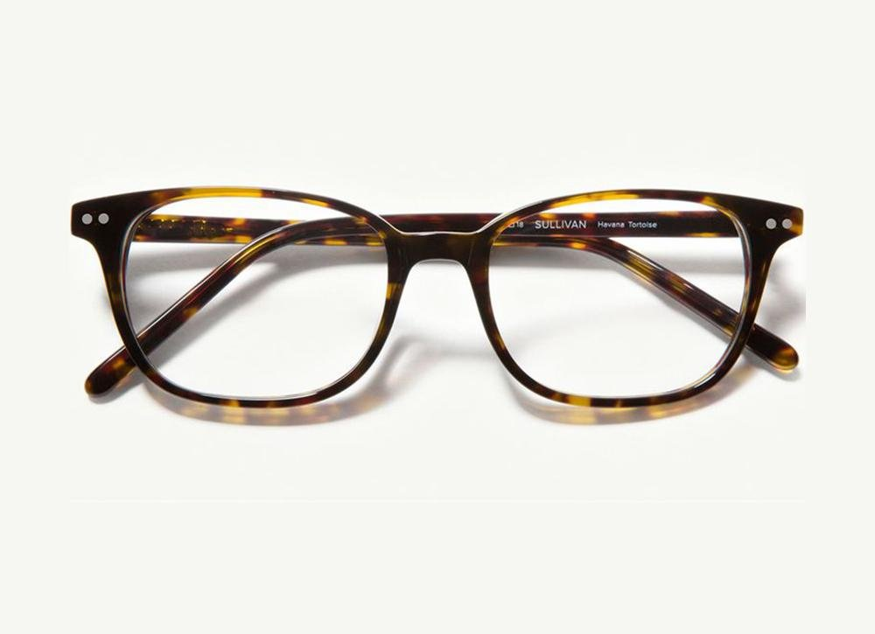

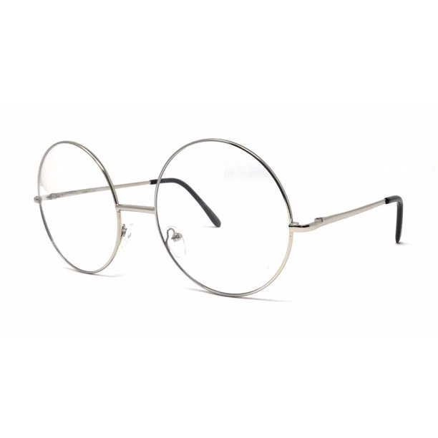

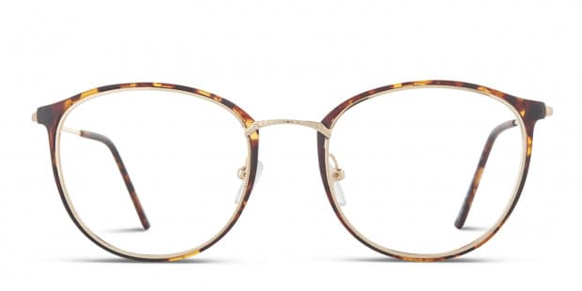

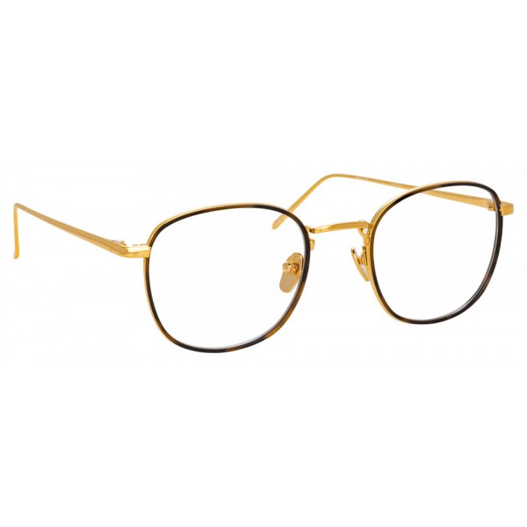

**CONTACT LENSES**

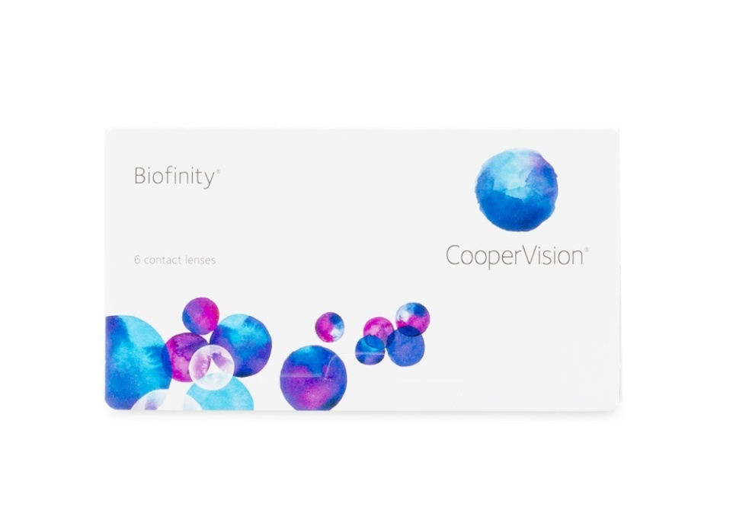

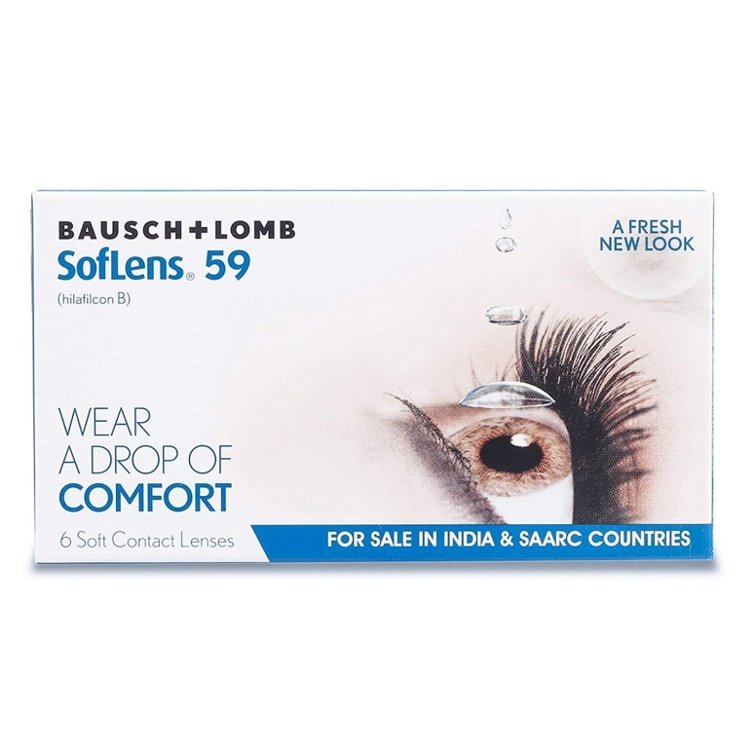

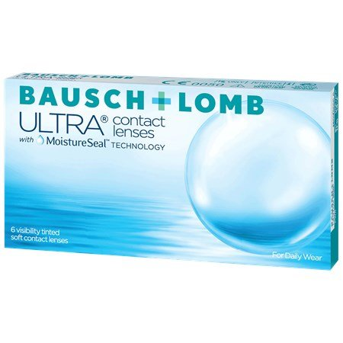

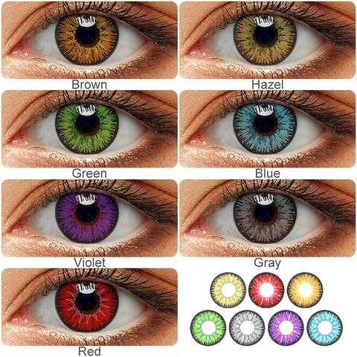

**MENS EYEWEAR**

